Ansible Role Demo (tasks, handlers, defaults, meta)

This document contains a minimal Ansible role (minrole) and the accompanying inventory and playbook files. Copy-paste these into your project and run the playbook.

- Create Role Folders
ansible-galaxy init minrole

2) Role Files

vi minrole/defaults/main.yml
# Lowest-priority defaults
—--
minrole_pkg: apache2
minrole_service: apache2
minrole_message: "Hello from minrole!"

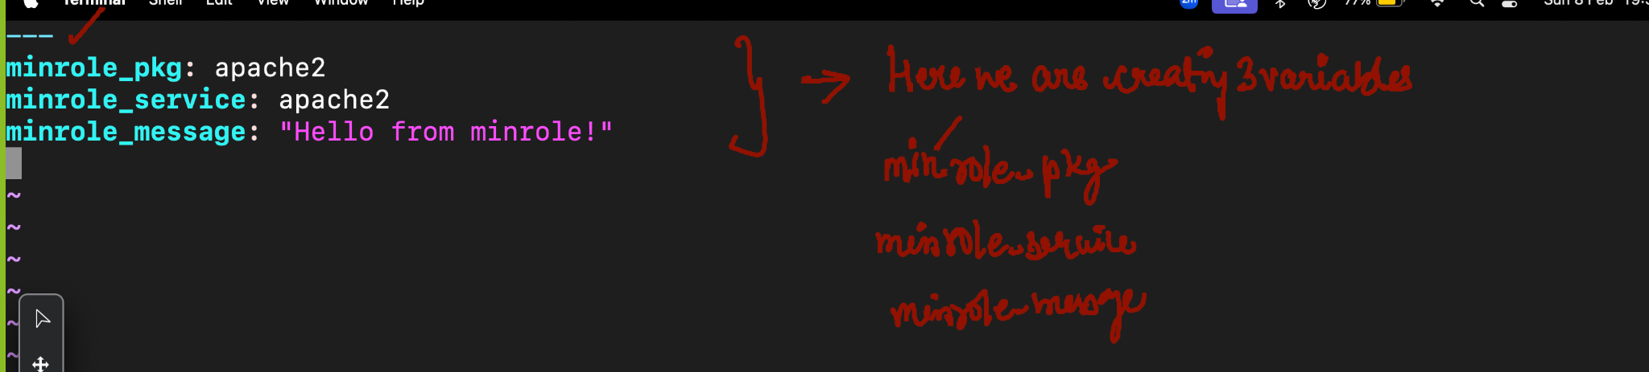
vi minrole/tasks/main.yml
---
# Static imports (parsed at load time)
- import_tasks: install.yml
- import_tasks: configure.yml

vi minrole/tasks/install.yml
---
- name: Install web server
package:
name: "{{ minrole_pkg }}"
state: present

- name: Ensure service enabled running
service:
name: "{{ minrole_service }}"
state: started
enabled: true

vi minrole/tasks/configure.yml
---
- name: Drop a tiny homepage
copy:
dest: /var/www/html/index.html
content: "{{ minrole_message }}"
mode: "0644"
notify: Restart web

vi minrole/handlers/main.yml
---
- name: Restart web
service:
name: "{{ minrole_service }}"
state: restarted

vi minrole/meta/main.yml
dependencies: []
cd /home/devops

It should be created outside the minrole
site.yml
---
- name: Apply minrole
hosts: all
become: true
roles:
- role: minrole

# (optional) override defaults here
# minrole_message: "Custom message!"
# minrole_pkg: httpd
# minrole_service: httpd

4) Run the Playbook
ansible-playbook site.yml

5) Validate Output
sudo cat /var/www/html/index.html

You should see: “Hello from minrole!”

Notes
- On RHEL/CentOS/Fedora set “minrole_pkg: httpd” and “minrole_service: httpd”.
- Handlers run only when notified (here: when the homepage content changes).
- “import tasks” is static (parsed at playbook load time).

End of document

